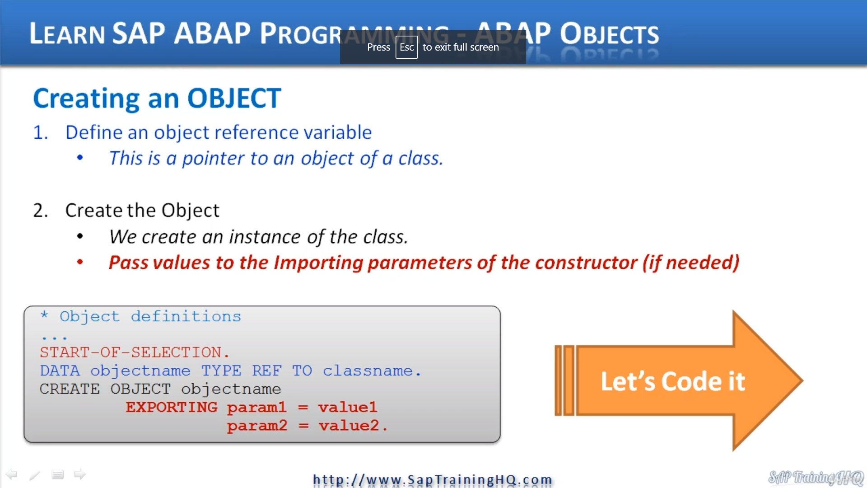

the create object statements, as you've seen in a previous video, we know we just must create object and then the object name and then the object gets created.

But when we have a constructor that requires parameters to be passed into it, we must specify these values that we want to pass.

Now, not all constructors will have important parameters so we can get away.

We just create objects and then the actual object name we give it.

But when there are important parameters, we must then extend the create object statement with the exporting keyword.

And when we do this we say exporting and we say the parameter that's the parameter from the constructor is equal to a value that we assign.

If there's more than one parameter, as in this case, we just keep listing them down.

It checks out fine, so if we just do a quick review, we've got to create object statement with the actual object reference variable we're exporting and we're failing in my duty to drop down here.

So, what we will do, let's create a brand-new method called Viewcar.

All this is going to be is a view in the car information that we pass in when we create the object.

So, let's come down here under the constructor and we will start with Method View car.

And all I'm going to do here is write out to the screen the information that belongs to this object.